**Assignment 03: Pokemon Data Analysis**

**Problem Statement:**

Implement the use case present in below blog link and share the complete steps along with

screenshot(s) from your end.

NOTE: You must submit a word file containing steps and screenshots.

https://acadgild.com/blog/pig-use-case-pokemon-data-analysis/

**Solution:**

Step 1: Placed Pokemon.csv file from Local machine to HDFS using put command, as shown below Pokemon.csv file is available in /user/acadgild/Pokemon.csv

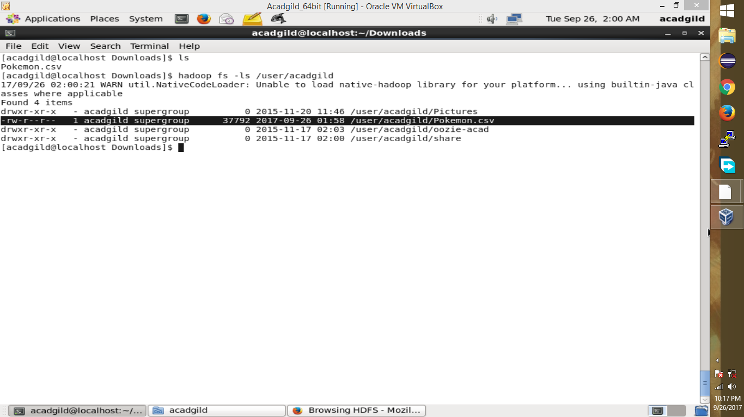

Step 2: As we are using Mapreduce mode I have run acommand Pig –x Mapreduce in the command line.

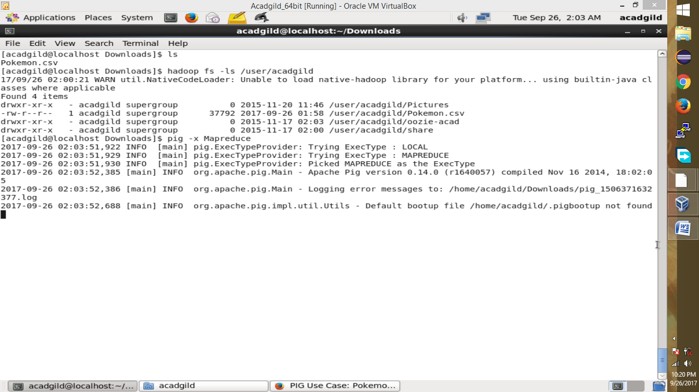

Step 3: in relation A we have loaded the pig data using below LOAD command on relation A.

A= LOAD ‘user/acadgild/Pokemon.csv’ USING PigStorage(‘,’) AS(Sno:int,Name:chararray,Type1:chararray,Type2:chararray,Total:int,HP:int,Attack:int,Defense:int,SpAtk:int,SpDef:int,Speed:int);

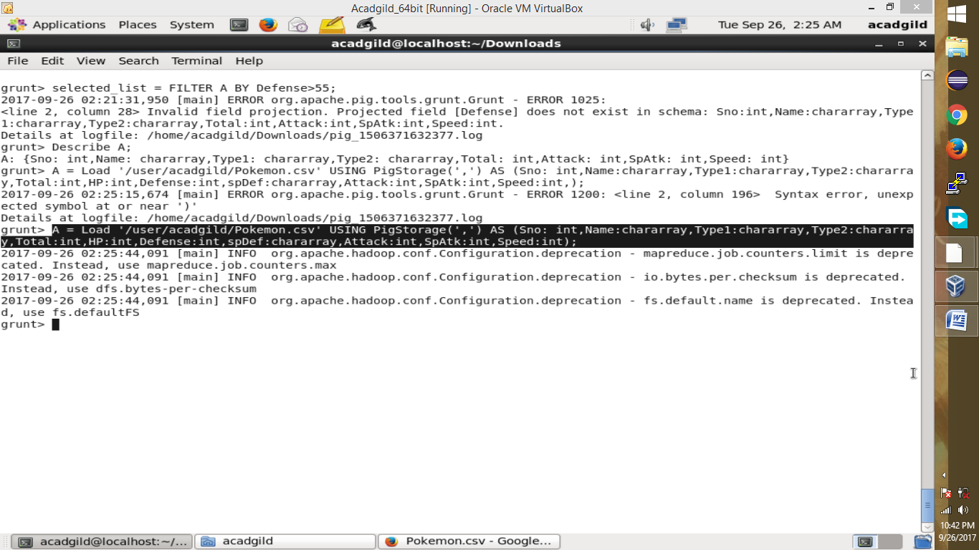

Step 4: Using DUMP A command we ca see printed data from Pokemon.csv file in grunt shell.

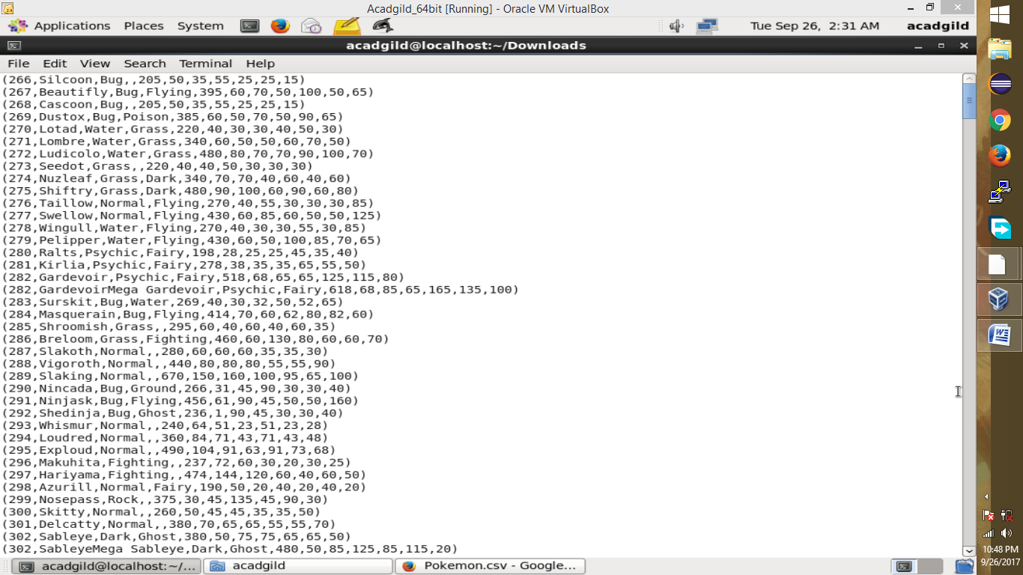

**Ques 1: Find the list of players that have been selected in the qualifying round (DEFENCE>55).**

The dataset is filtered, and hence out of all the 800 Pokemons, only 544 are eligible to take part in the tournament.

Below commands are used to filter the selected player:

selected_list = FILTER A BY Defense>55;

DUMP selected_list;

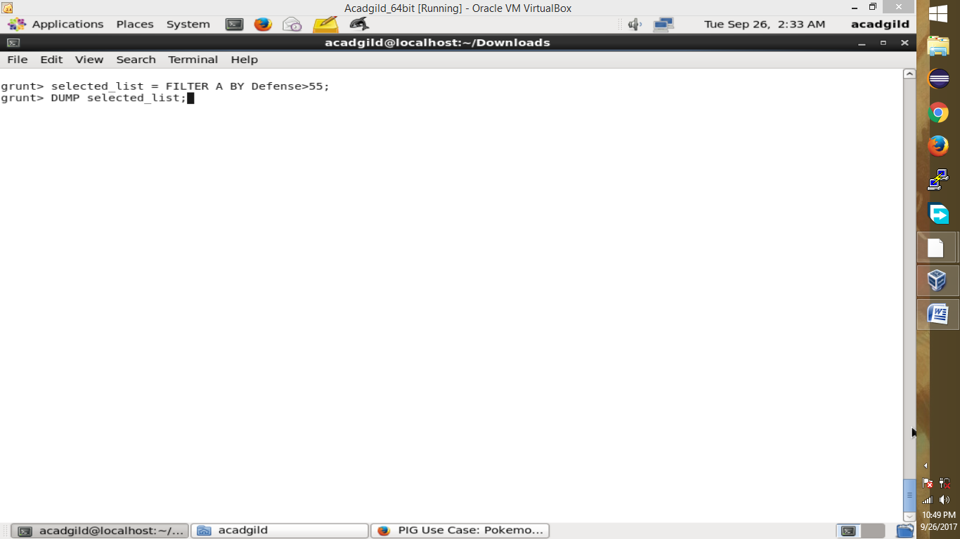

All 544 eligible pokemons are displayed in grunt dhell below:

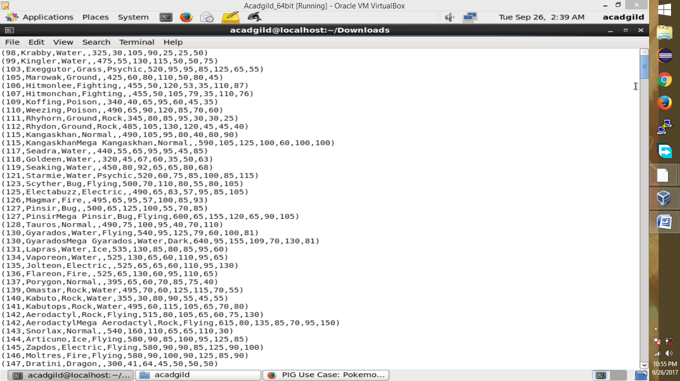

#### Ques 2: State the number of players taking part in the competition after getting selected in the qualifying round.

So, All the 544 players taking part will be alphabetically arranged and two teams of 5 Pokémons need to be extracted out randomly from the earlier list.

gourp_selcted_list = Group selected_list All;

count_selcted_list = foreach gourp_selcted_list GENERATE COUNT(selected_list);

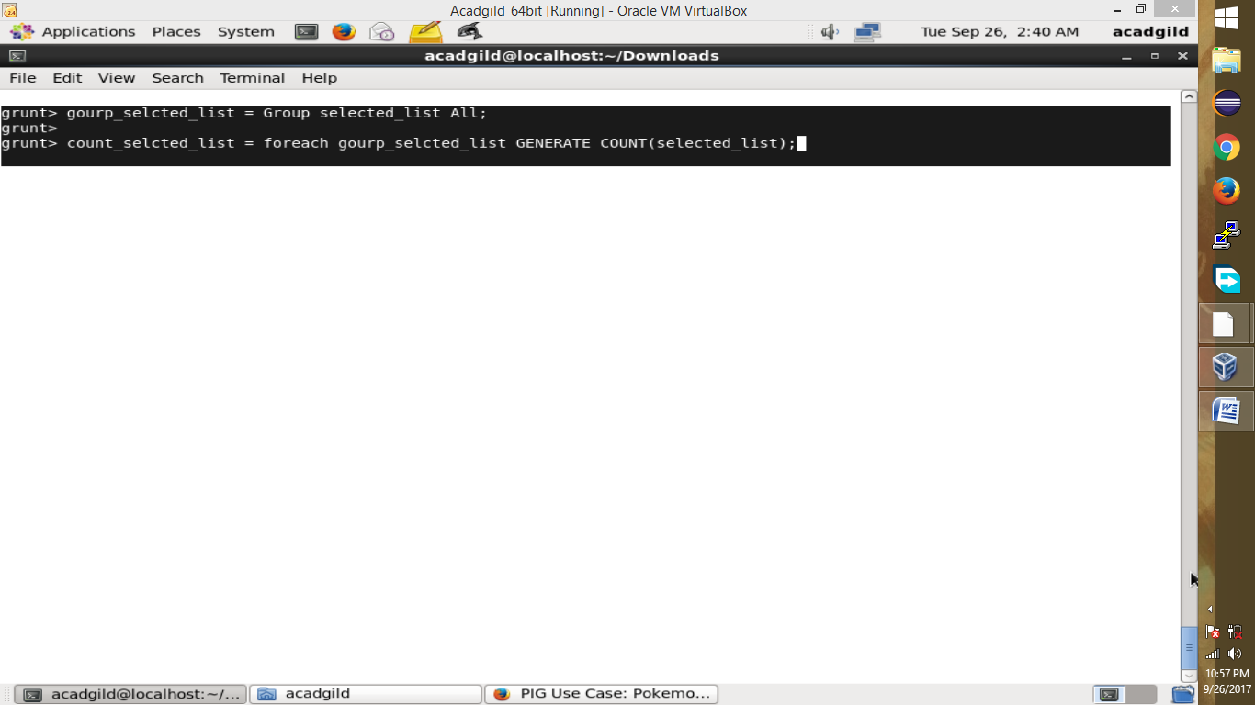

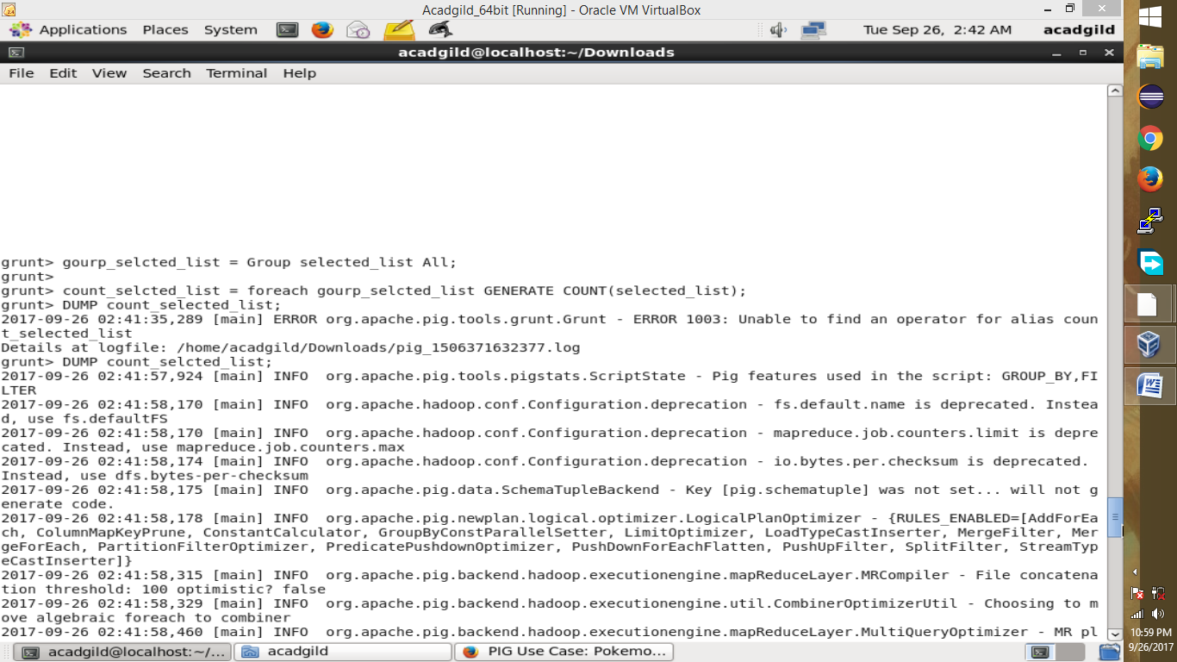

In below screen total:544 count is printed.

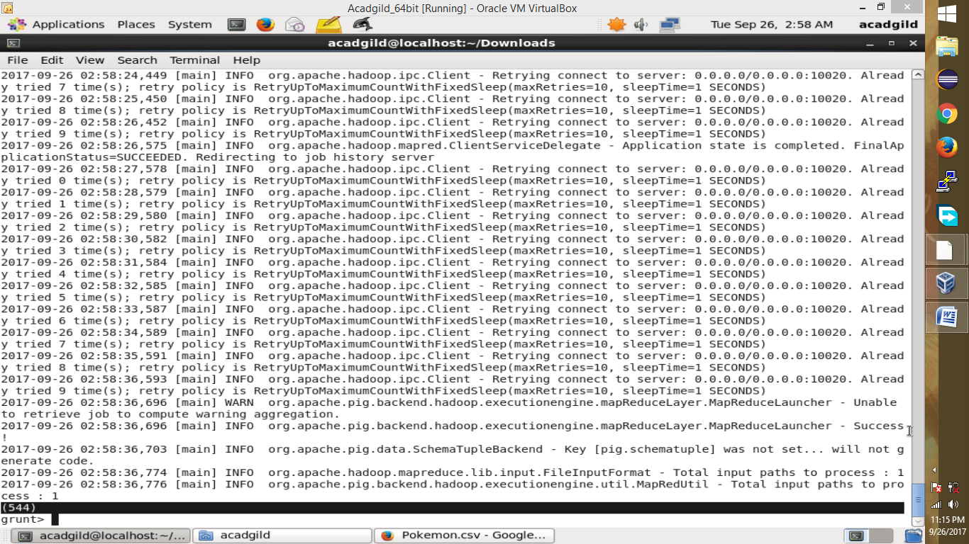

#### Ques 3: Using random() generate random numbers for each Pokémon on the selected list.

*Command*

random_include1 = foreach selected_list GENERATE RANDOM(),Name,Type1,Type2,Total,HP,Attack,Defense,SpAtk,SpDef,Speed;

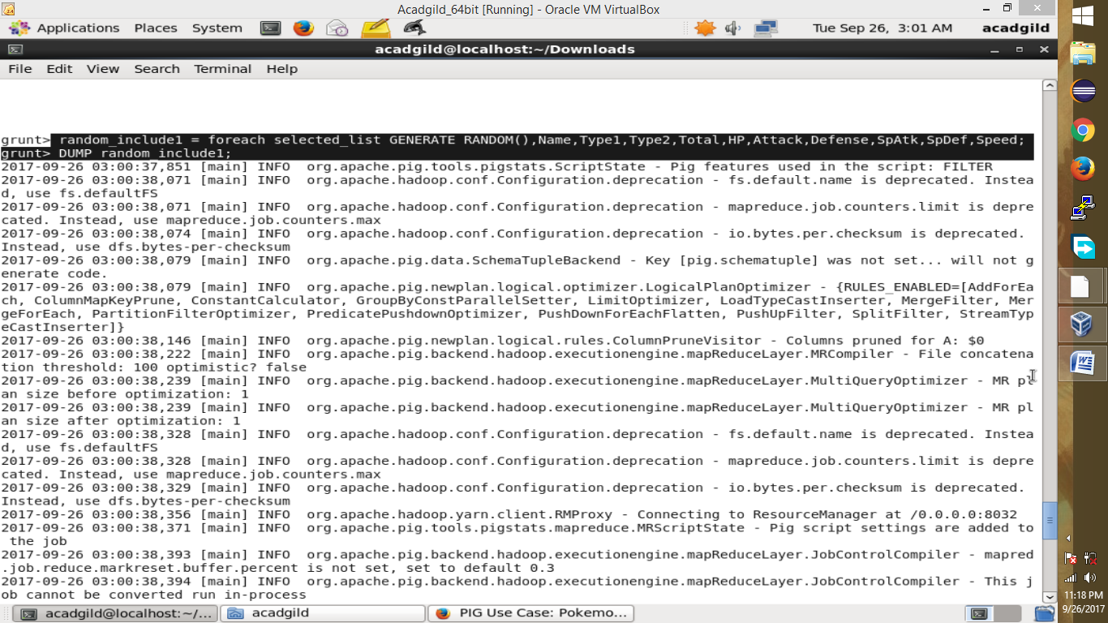Hence sample for the list after adding random numbers:

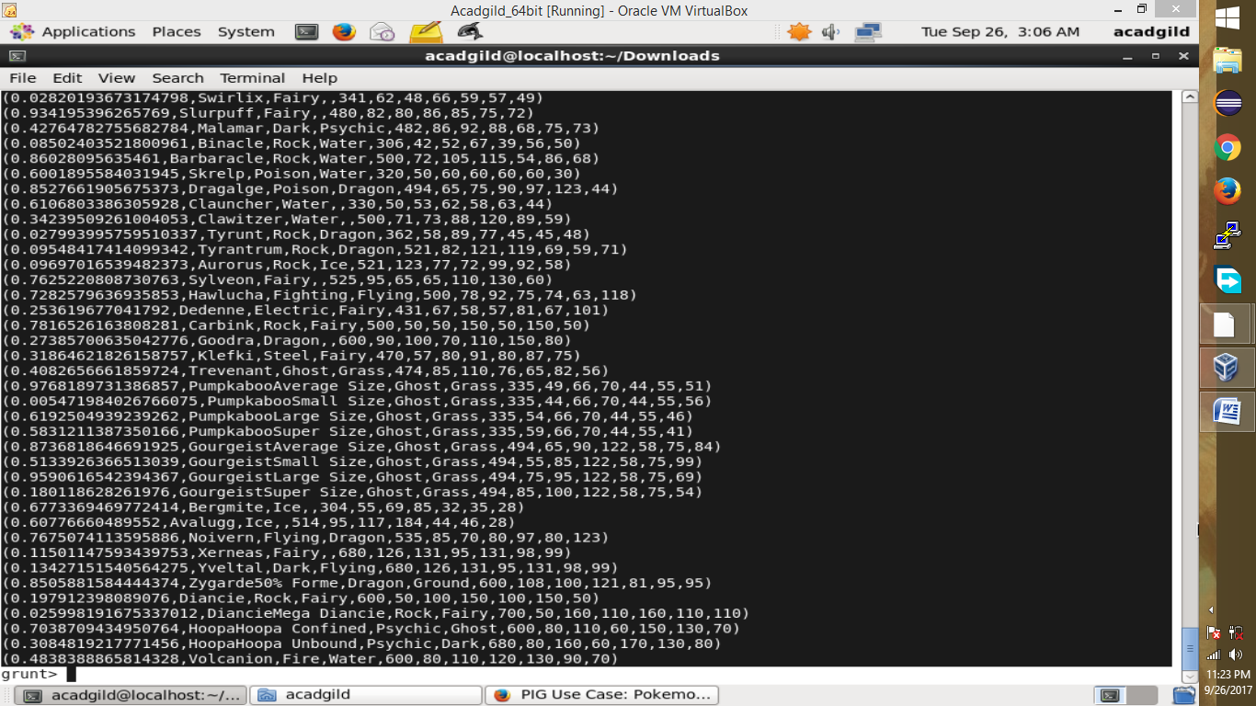

#### Ques 4: Arrange the new list in a descending order according to a column randomly.

#### Explanation: This will give us consequently a layer arranged to pick the random list which 1st player will choose.

#### *Command*

#### random1_desending = ORDER random_include1 BY $0 DESC;

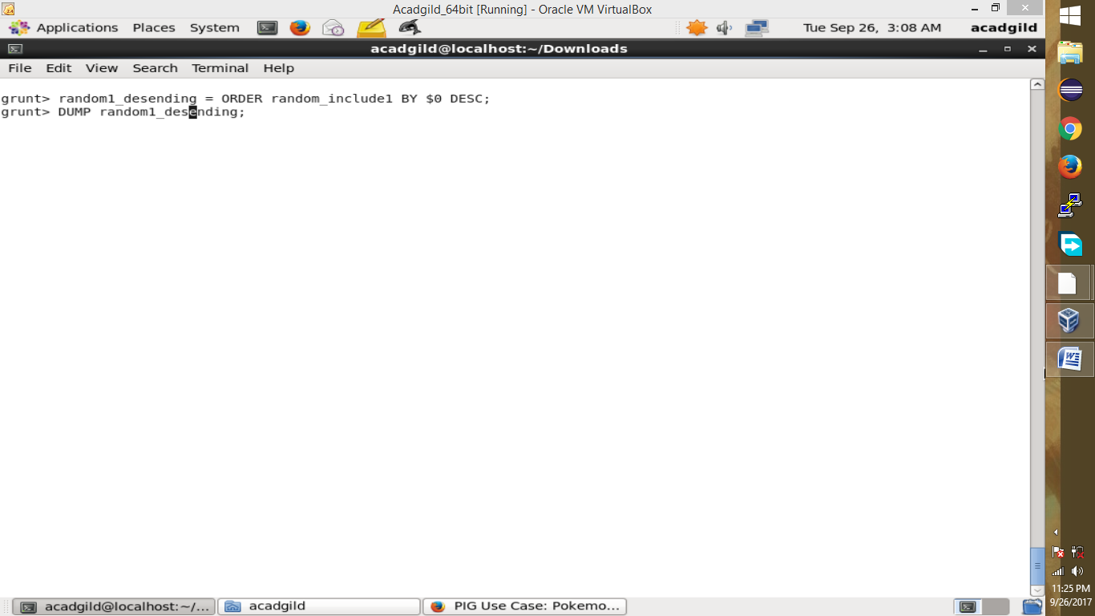

Hence the sample for the list after the query.

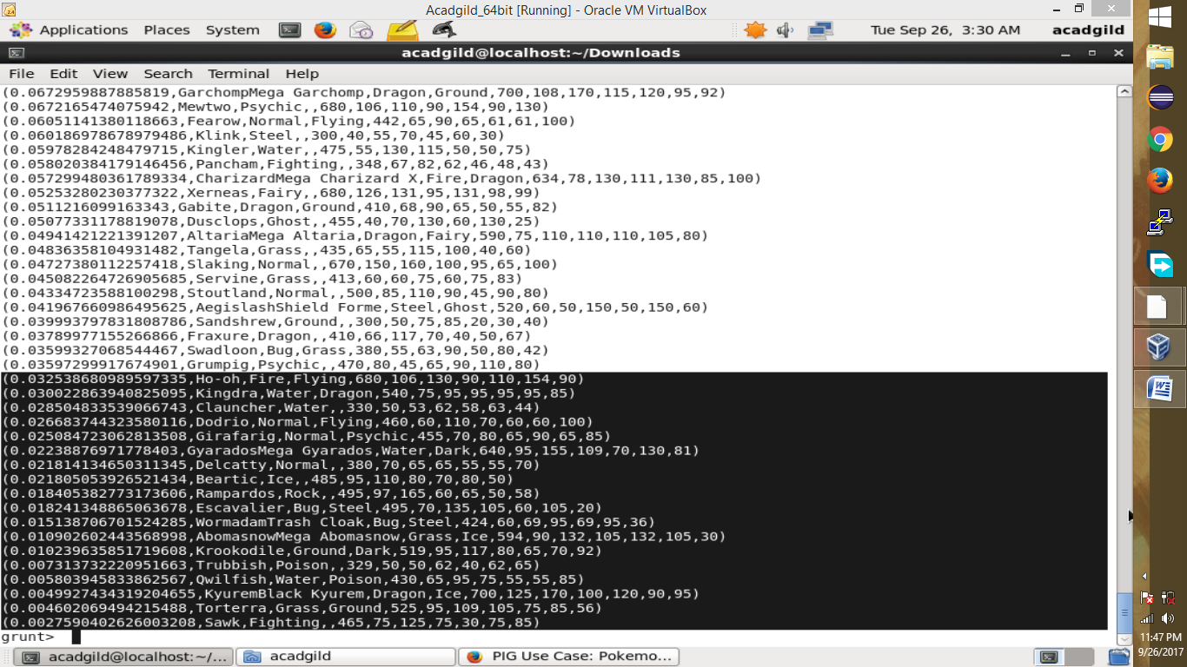

#### Ques 5: Now on a new relation again associate random numbers for each Pokémon and arrange in descending order according to column random.

**Explanation**: We will be repeating above two steps again to form the 2nd list.

*Command*

random_include2 = foreach selected_list GENERATE RANDOM(),Name,Type1,Type2,Total,HP,Attack,Defense,SpAtk,SpDef,Speed;

random2_desending = ORDER random_include2 BY $0 DESC;

DUMP random2_desending;

Hence sample for the list.

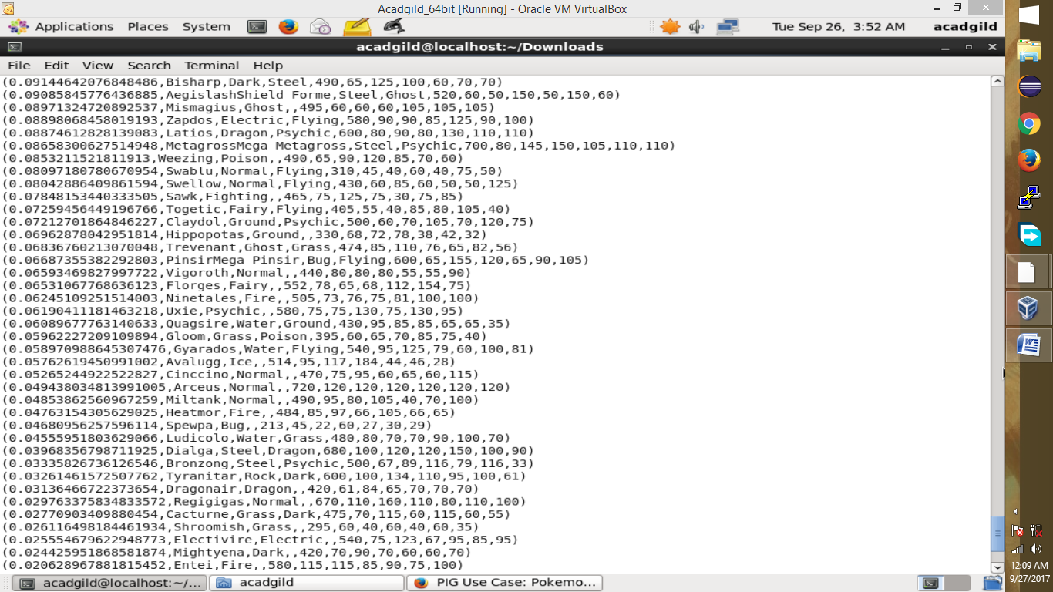

**Ques: From the two different descending lists of random Pokémons, select the top 5 Pokémons for 2 different players.**

Explanation:

*Commands*

limit_data_random2_desending = LIMIT random2_desending 5 ;

DUMP limit_data_random2_desending;

Since for Player1 we have:

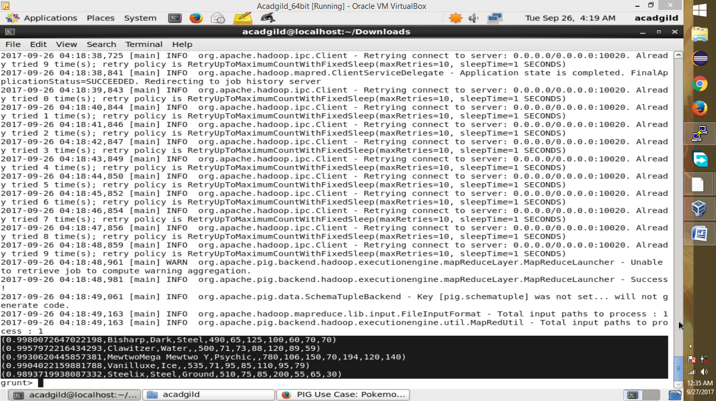

limit_data_random1_desending = LIMIT random1_desending 5 ;

DUMP limit_data_random1_desending;

Since for Player2 we have:

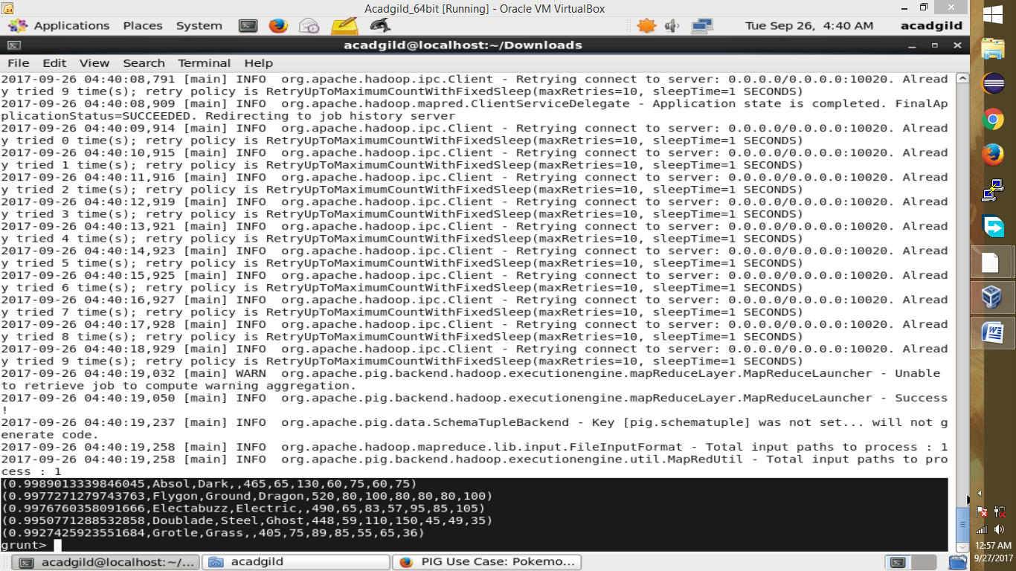

**Ques: Store the data on a local drive to announce for the final match. By the name player1 and player2 (only show the NAME and HP).**

**Explanation**:

*Commands*

filter_only_name1 = foreach limit_data_random1_desending Generate ($1,HP);

DUMP filter_only_name1;

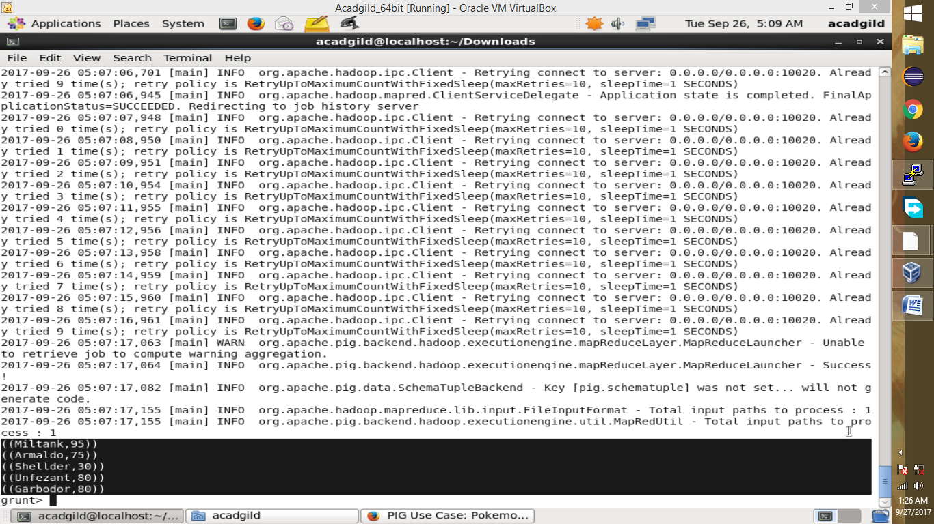

filter_only_name2 = foreach limit_data_random2_desending Generate ($1,HP);

DUMP filter_only_name2;

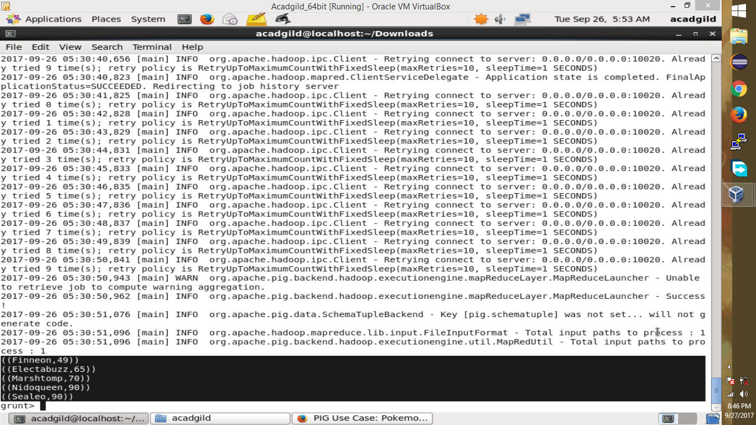

Therefore querying is over using some simple pre-defined functions to get 2 sets of 5 Pokémons, which get select randomly.

In conclusion, let’s store this result in our local system  so we can use it as input to our next blog. Especially relevant where we will see UDF using PIG and calculations will be done through user-defined formulas.

STORE limit_data_random1_desending INTO ‘/user/acadgild/PIG/player1.txt’;

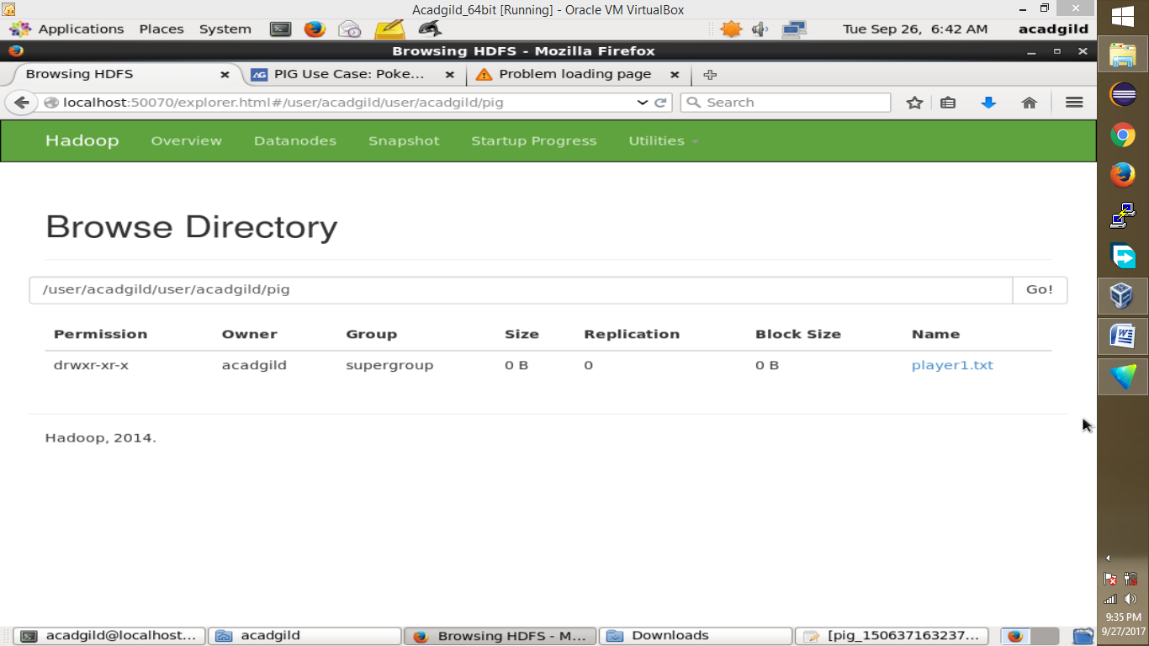

As a Result:

STORE limit_data_random2_desending INTO ‘/user/acadgild/PIG/player2.txt’;

As a Result:

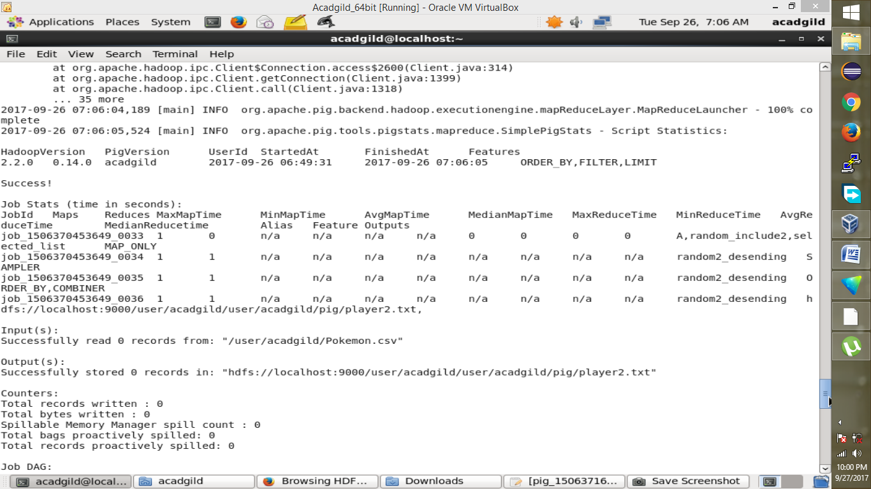

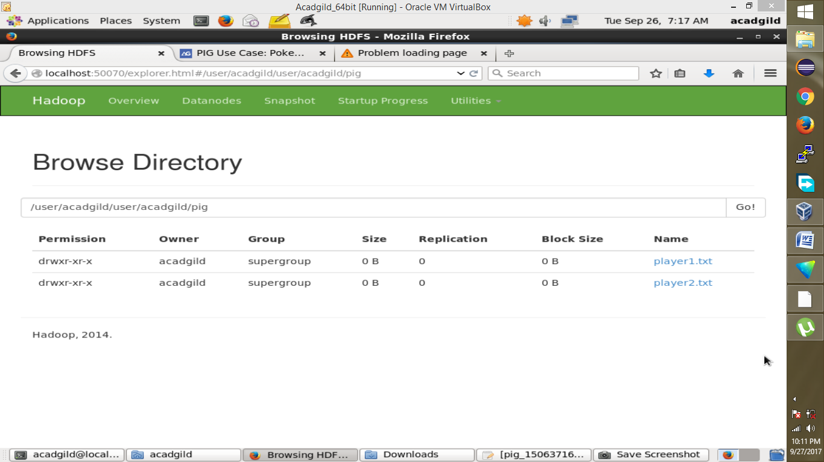

As a result, the Pokémons for both players got selected . This player will be fighting consequently in the Finals with their respective Pokémons assigned.